The BCH codec synthesis system
In this chapter the BCH codec synthesis (BCS) system is described. This tool allows the user to enter the parameters of a particular BCH codec and a VHDL model of this codec is then automatically generated. The VHDL models are written in such a way that they can be synthesised down to gate level and thereby transported to an FPGA for example. The BCS systems therefore provides a direct link from the parameters of a BCH code to its implementation. The system also allows the user to make choices on the generated codec architecture, such as whether elements of the circuit operate in series or in parallel and which decoding algorithms are to be used. The user is further given the option of generating command files to assist with simulation. A report file detailing information such as the hardware requirements of the codec is produced.

The design approach
The BCS system is a combination of a C program (bch.exe) and a number of VHDL templates. VHDL can act as a high level programming language much like C and so it would have been possible to design the whole system using VHDL [47]. With this approach, the various parameters of the code and structures of the required finite field arithmetic operators would have to be calculated by VHDL procedures and functions. These relatively high level constructs would then have to be incorporated into lower level VHDL designs to allow for synthesis to ultimately take place. This, in conjunction with the lower execution times of C programs as opposed to VHDL programs ruled against a purely VHDL solution being adopted.

Instead, a hybrid C/VHDL methodology was employed. With this approach the crucial finite field and BCH code parameters were generated by a C program. These values were then copied into a VHDL template to generate the overall VHDL model of the BCH codec. This combination of VHDL and C is not a new solution [51]. As VHDL does not directly support every requirement it is often beneficial to go beyond its limitations by using additional C programs [18,51]. Therefore the choice between using purely VHDL or a hybrid system depends on the individual application. The advantages of the presented hybrid solution are summarised below.

- The design can be targeted to synthesis by writing the models at a lower level of abstraction.
- C programming is more advanced than VHDL and so more sophisticated functions are available. This significantly shortens design times.
- Design optimisation can be included into the system.
- The overall system is faster as C executes in less time than VHDL and C code optimisation is not so important.
- VHDL files generated by a C program have fixed logic (i.e. they model only one BCH code), and thus an additional level of logic checking is available. This is a crucial design feature, as these files can be easily edited and any errors found quickly.
- The C program can generate simulation command files.
- The C program can generate a report file (sim.txt).
- The user interface is more friendly.

The disadvantages of employing the hybrid approach are as follows:
- The concatenation of a C program with VHDL-like template files is sometimes difficult to achieve, e.g. the templates cannot be freely edited.
- The VHDL text that is inside the C input file (bch.c) is unreadable.
- For a large BCH code, long and thus unreadable VHDL files are generated.
- The final VHDL files are developed using the C program and VHDL-like templates files, thus error editing is more difficult because two or more files must be referred to. For example if an error is found in a final VHDL file by the VHDL compiler, the modification must be made to the C language input file or/and the VHDL template file. This is only a development issue however.

Design structure

Overview
The BCS system is broken down into two parts:
- A C program (bch.exe) - This program accepts the design parameters of the codec such as the code’s block length and error-correcting ability as provided by the user. Using these parameters and the VHDL templates, bch.exe determines the design of the encoder and decoder. In addition, the C program generates a simulation file and the necessary command files and a report file.
- Powerview - After the C program has generated the VHDL files, these files are synthesised and simulated using the Powerview ECAD suite.

The most vital concept of this approach is the communication between the C program and the Powerview synthesis tool (PVST). The inputs to the PVST are VHDL text files which are generated by the C program using basic C language constructs and sophisticated text processing functions. Therefore it is possible to generate a complete VHDL text file at the RTL/logic level, as the complicated finite field arithmetic operator structures can be designed more easily by the C program rather than by a VHDL model.

Some parts of the BCH codec descriptions can be easily written in VHDL without using the C program. In addition, including the complete VHDL text into the C program may be difficult, particularly if a large VHDL file is considered. For example, VHDL text inserted into the C program is rather illegible and it significantly increases the C file size.

The solution is the use of VHDL templates. These files contain parts of VHDL that can be easily specified for every BCH code and therefore they can be written at a low level of abstraction. The C program reads these templates and copies them into VHDL files. While copying, the C program also inserts parts of text which are difficult to determine for every BCH code and must be calculated using sophisticated C functions. The places in the templates where the C program inserts text are marked by the ‘#’ character. Therefore the C program can copy templates without analysing them. It only checks if a copied character is the ‘#’ character, if it is, the C program stops copying and it inserts text into the VHDL file. In conclusion the templates can be edited (without changing the C program) as long as a ‘#’ character is not changed or rearranged. As an example, the method of obtaining the control system (counter) for the encoder is presented in Appendix E.

The BCS system uses a number of different files, and this structure is illustrated in Fig. 4.1 and described below.
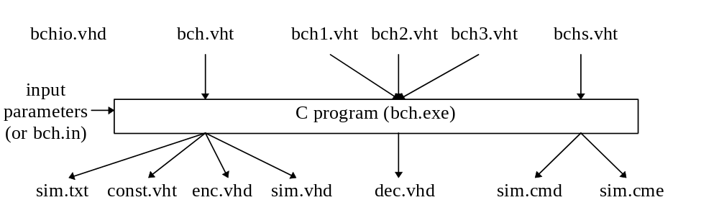Figure 4.1. File structure of the BCS system.

C program file:
- bch.exe - the C compiled executable program that controls the BCS system.

Input file with design parameters:
- bch.in - this is an input text file which contains the selected BCH code parameters and the C program options. These values are entered into bch.in by the BCS system user.
m= - specifies the size n of codeword (n, k) where n= 2^{m}-1. (3≤ m ≤10)
t= - specifies the number of errors the code is capable of correcting.
-o - specifies the BMA architecture (only for t ≥3)
2- parallel inversionless
3- serial with inversion (recommended)
-i - interleave parameter, only for the BMA (for t≥3, see Section 4.4.3.1)
-m - design minimisation by extraction (see Section 4.7)
0 - without minimisation
1,2, ... - the minimum number of common expressions minus one to be replaced by the new sub-expression.
-s - generate sym.cmd and sym.cme simulation command files with the specified number of codewords to be simulated. If -s0 do not generate simulation command files.
Note, that if the bch.in file cannot be found, the C program will request these parameters to be typed into its interface.

Templates:
- bch.vht - for generating sim.txt, const.vhd, enc.vhd and sim.vhd
- bch1.vht - for generating dec.vhd (for SEC codes)
- bch2.vht - for generating dec.vhd (for DEC codes)
- bch3.vht - for generating dec.vhd (for TMEC codes)
- bchs.vht - for generating sim.cmd and sim.cme for simulation purposes.

Output VHDL files:
- const.vhd - contains the most often used constants (e.g. n, k, t). These constants are available to the VHDL entities by inserting the statement “USE WORK.const.ALL;” at the beginning of entity files. This ensures that the constants need not be inserted into templates each time by the C program. (See Appendix F).
- enc.vhd - contains the VHDL description of an encoder.
- dec.vhd - contains the VHDL description of a decoder.
- sim.vhd - contains the VHDL description for simulation purposes.
- bchio.vhd - contains additional input/output interface descriptions (this file is not generated by the C program and requires only constants included in the const.vhdl file).

Other output files:
- sim.cmd - a simulation command file used to simulate the VHDL description of the codec before synthesis is applied.
- sim.cme - a simulation command file used to simulate the gate level description codec generated by the PVST.
- sim.txt - a report text file. This file contains:
- a description of the design files used by the BCS system
- a description of the C program input parameters
- a list of the BCH codes that the BCS system can operates upon
- the hardware requirements and the description of the design entities used in the encoder and decoder.
- a table of GF(2^{m}) for the selected m, for polynomial and dual basis representations.

The C program
The most important element of the BCS system is the C program (bch.exe). This contains over 2000 lines of code and it is outside of the scope of this thesis to describe them in great detail. Accordingly, the most important functions of the C program are considered below.
- The bch.in file containing the design parameters is read in. If this file cannot be found the user is requested to enter the parameters of the BCH code and these parameters are analysed. If these parameters are incorrect an error message is displayed. The C program also calculates optimum values of the BCH codec options, therefore if the user does not specify some parameters (e.g. by typing 0) the optimum value is taken.
- The template file bch.vht and the report file sim.txt are opened. Then the C program copies some part of the text from the template (bch.vht) into the report file (the description of the BCS system files and its input parameters)
- The generator polynomial for the encoder is generated using the entered values of m and t. This calculation employs equ(3.1) and is the most complicated GF operation carried out. During this calculation, other BCH code parameters for the selected m are determined and exported into the report file sim.txt. In addition, the error correction capability t is verified, that is, it is checked that there exists a BCH code with the specified value of t. The degree of the generator polynomial is exactly the number nk= n-k (n= 2^{m} -1) and in this way the BCH code parameter k is found.
- The file const.vhd is generated using bch.vht. This const.vhd file contains the most important design constants.
- The encoder VHDL description (enc.vhd) is generated using bch.vht.
- When writing to enc.vhd (or later to dec.vhd ) the entity names and numbers of XOR gates and flip-flops used are determined and exported to the report files. The C program does not analyse the templates in order to find the hardware requirements but calculates these values internally.
- The VHDL file sim.vhd is generated for simulation purposes using bch.vht.
- The VHDL decoder description (dec.vhd) is written using one of the files bch1.vht, bch2.vht or bch3.vht, according to the selected error correction capability, be it SEC, DEC or TMEC.
- The simulation command files sim.cmd and sim.cme are generated to simulate the entity included in the sim.vhd file.

This C program contains neither a list of BCH codes that may be described nor any of their parameters, these are all calculated by the system. bch.exe only contains information about irreducible polynomials for m=3 to 10 (see Appendix A). GF multiplication is carried out using the multiplication by α method, similar to the one illustrated in Figure 2.1. Multiplication of 2 variable elements in GF(2^{m}) is carried out by a method similar to that implemented in Figure 2.4 (SPBM option M).

The Powerview Synthesis Tool (PVST)
In this design the PVST has been employed [52]. The Powerview suite consists not only of a synthesis tool but also a VHDL analyser and a simulation tool. Therefore a design can be developed at a high level using VHDL and then simulated. This enables top-down design development and simplifies the finding of errors during synthesis. As the PVST has proved unsuited to carrying out synthesis at the high level, these designs have been developed almost at the logic level.
Note that none of the PVST built-in design entities (e.g. VA_NANDk, VA_ONE_PLUS) or other PVST functions have been employed, and so the designs can be synthesised by other synthesis tools as well.

The Encoder
The encoding process has been described in Section 3.3, and so now, only the VHDL model of an encoder is considered. BCH encoders consist of two entities, an LFSR (entity name - ering) and a control system (ecount). As an example, an encoder for a (15, 5) triple error correcting BCH code is presented in Appendix G. The feedback connections of the LFSR are calculated in the C program and then exported into the VHDL text file.

The control system consists of a modulo n counter and an additional flip-flop which is synchronously set when the counter equals 0 and reset when the counter equals k, (the flip-flop output is 1 for count ≤k-1, otherwise 0). The state of the register controls the switches S1, S2 (see Figure 3.1).

The input/output interface of the encoder consists of the following signals:
- reset (input)- to (synchronously) reset the encoder and synchronise the encoder with the decoder
- din (input)- the data input
- dout (output)- the encoded data to be transmitted along the potentially noisy channel
- clk (input)- the clock signal to clock both the input information and the encoded data
- vdin (output)- a valid data in signal. A high level on this signal shows that information data is being clocked with clk. This signal works as the clock enable signal for the din input. Consequently at first the encoder receives information data (vdin=1) and simultaneously sends it. Then the encoder sends the internally calculated parity bits, and so information data is not accepted (vdin=0).

The encoder input/output interface of the encoder is shown in Fig. 4.2
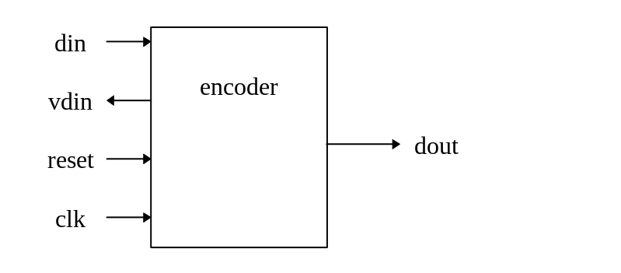
Figure 4.2. The input /output interface of the encoder.

There is also an alternative interface included in the bchio.vhd file. With this interface there are two different clocks, the clk signal shown above and the clkio signal which has a lower frequency. This interface requires additional hardware and is necessary when input pipelining is required.

The decoder
Generally the decoding process is broken down into three different steps:
- syndrome calculation, as considered in Section 3.4.1. An example of the syndrome circuit for the (15,5) BCH code is given in Appendix H, (see also Section 4.7 on syndrome optimisation).
- the BMA, introduced in Section 3.4.2 and considered below.
- Chien Search, as presented in Section 3.4.3. An example of this circuit is presented in Appendix I.
In practice, some extra entities are required such as a control system, a buffer and a syndrome rearranging circuit for the BMA.

The input/output interface of the decoder consists of the following signals:
- reset (input)- to (synchronously) reset the decoder and synchronise it with the encoder
- din (input)- the input data
- dout (output)- the corrected data
- clk (input)- the clock signal to clock both the received data and the output data
- vdout (output)- a valid data out signal. A high level on this signal indicates that dout should be clocked with clk. This signal works as the clock enable signal for the dout output.

The input/output interface of the decoder is presented in Figure 4.3.
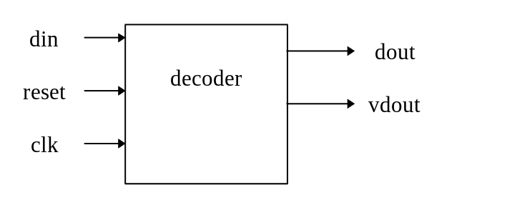
Figure 4.3. The input/output interface of the decoder.

There is also an alternative interface included in the bchio.vhd file. With this interface there are two different clocks, the clk signal shown above and the clkio signal which has a lower frequency. This interface requires additional hardware and is necessary when output pipelining is required.

For the decoding process three different algorithms have been adopted for SEC, DEC and TMEC codes.

Single error correcting decoders
Single error correcting BCH codes represent the simplest group of BCH codes and are also known as Hamming codes. The decoder consists of four blocks: a syndrome calculator, a Chien search circuit, a buffer and a control (counter) system. The block diagram is given in Appendix M. Single error correction requires relatively simple hardware but is capable of correcting only one error and so cannot be implemented in more sophisticated error control systems. SEC codes may be also implemented as parallel-in parallel-out systems (e.g. 16/32 SN54ALS616 / SN54ALS632 [50]), thus corrected data is available almost immediately on the output of the decoder. In spite of this, the architectures presented in this thesis employ cyclic code properties and so all the encoders and decoders are serial-in serial-out.

Double error correction decoders
For double error correction (DEC) decoders two different algorithms may be used. The first algorithm employs the equation presented below instead of the BMA:
σ₁(x) = S₁ + S₁²x + (S₁³ + S₃) x². (4.2)
Equ(4.2) is obtained by multiplying equ(3.21) by S₁. This algorithm is slightly less hardware-efficient (for a parallel solution) than the algorithm presented below and therefore is not used in this thesis. In spite of this, the algorithm may also be considered if the circuit for raising to the power three is implemented using squaring and bit-serial multiplication. Note that the second algorithm requires the raising to power three to be carried out in parallel, therefore for large m the first algorithm may be beneficial.

The second DEC algorithm implemented in the BCS design was presented by Wei et al. [53] and has been described in Section 3.4.3.2. Its block structure is given in Appendix N. The DEC circuit includes a syndrome calculator and a similar Chien Search circuit as for the general case. The DEC circuit consists of the circuit for raising to the power three, which was considered in Section 2.6.2. In Section 2.6.2, two approaches for raising to the power three were considered - the standard method based upon squaring and multiplication and a new approach. In the BCS system the new approach has been adopted. An example of exponentiation for GF(2⁵) is given in Appendix J.

Triple and more error correction decoders
TMEC decoders consist of three independent blocks:
- a syndrome calculator (a syndrome calculator for a (15,5) BCH code is presented in Appendix H)
- the BMA unit
- a Chien search unit (a Chien search unit for a (15,5) BCH code is presented in Appendix I)
In addition, a syndrome rearranging circuit, a buffer and control blocks are also required. The block structure of a BCH decoder is presented below.
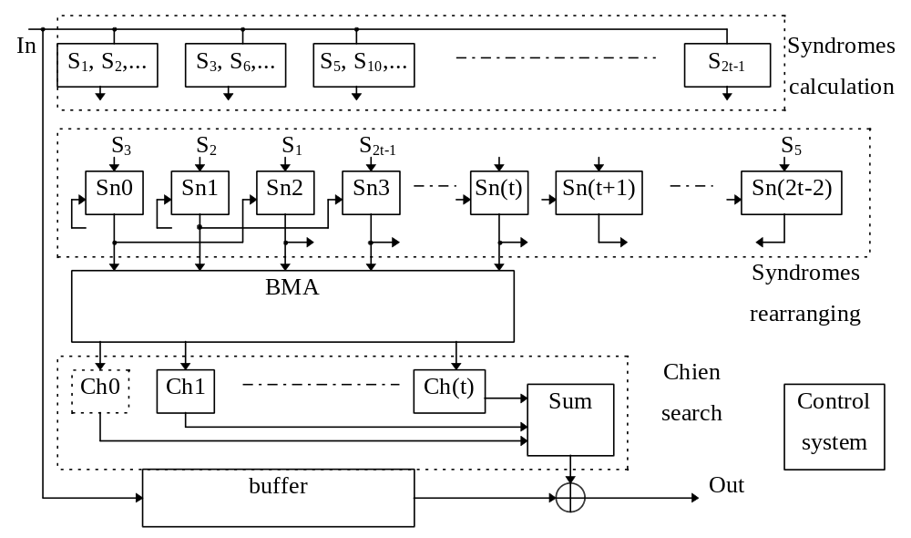Figure 4.4. Block diagram of the decoder circuit.

The most difficult and hardware-consuming of these steps is the second step - the BMA. In this thesis two different approaches for the BMA have been considered:
- with inversion
- inversionless.

The BMA with inversion
The block structure of the BMA is given in Appendix O. For the BMA (see equ (3.18)) the most hardware consuming equations are:
(4.3)
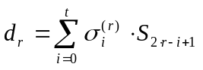 (4.4)
and 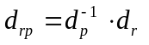.
Substituting σ_{j}^{(r)} from equ (4.3) into equ (4.4) we obtain
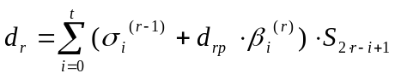 . (4.5)
Equ (4.5) can be implemented using the Dual Polynomial Basis Multipliers (DPBMs) given in Section 2.4.6. Consequently, as only one value d_{rp} is required (see equ(2.32)), the option B multiplier is used to generate this product. In addition, the most efficient circuit calculating equ(4.4) is the circuit calculating the sum of products presented in Section 2.4.5. It can be observed that two above circuits can be easily combined and so additional circuit savings can be made. The circuit implementing equs(4.3) and (4.4) is presented below
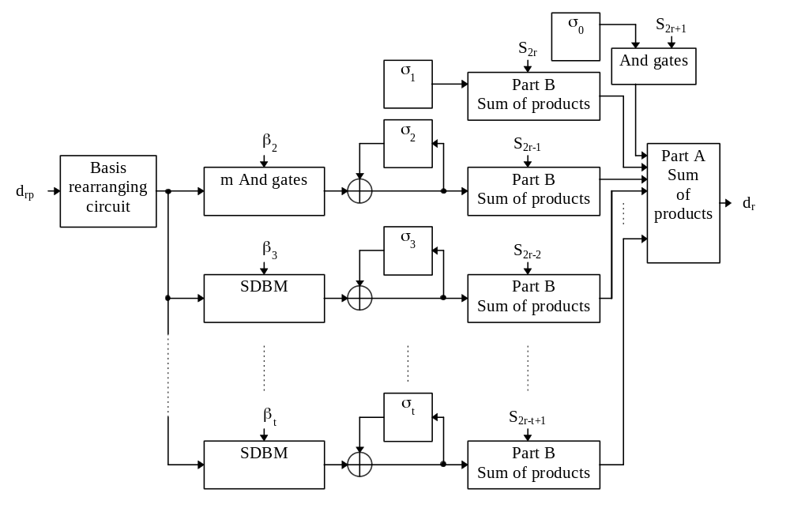Figure 4.5. Circuit implementing equs(4.3) and (4.4) in the BMA. (see also Figs. 2.6 and 2.9)

It can be seen from equs(3.17) and (3.18) that the value σ₀ is always 1 and σ₁ always equals S₁. Similarly β₀ and β₁ are zero, and β₂ equals either 0 or 1, therefore some multiplications can be significantly simplified using only AND gates.

The new approach to the BMA significantly reduces hardware because the DPBM and the sum of products circuits are particularly hardware efficient. In addition, neither of the β_{i} or S_{j} values are lost nor rotated during multiplication and therefore neither additional registers nor additional multiplexing is required. On the other hand, using the standard approach when the Berlekamp multiplier is used, the values in the LFSR (see Fig. 2.2) are lost during calculation and therefore extra registers are needed to restore these values. When normal basis multipliers are used the rotation operation is required (i.e. additional multiplexing) furthermore, the hardware requirements of normal basis multipliers are significantly higher then those of the presented approach.

It should be noted here that only one relatively expensive basis rearranging circuit for the DPBM is required. Therefore even if the irreducible polynomial for the basis is a pentanomial (only for m=8 for the considered codes), the DPBM can be efficiently implemented.

For this algorithm the division (inversion and multiplication) d_{rp}= d_{r} * d_{p}⁻¹ is required. A circuit to carry out this division has been presented in Section 2.7 and in Appendix L. In the inversion operation the bit-parallel dual basis multiplier is used, as the result d_{rp} is required in the dual basis (for the DPBM) and it is hardware efficient and easy to design (see Appendix K). This circuit requires (m-1) clock cycles to carry out the inversion d_{p}⁻¹. Fortunately, the result of the inversion is needed after the next iteration of the BMA and thus the inversion operation is not time critical. In addition, one clock cycle is required after the d_{r} value is available to carry out the parallel multiplication d_{r} * d_{p}⁻¹ (this multiplication is implemented using the same parallel multiplier as in the inversion).

One of the most important features of the DPBM option B is that the time taken to operate is halved. To implement equs(4.3) and (4.4) only (m+1) clock cycles are required. The additional one clock cycle is due to the additional flip-flops (actually one of the σ_{i} flip-flops) between SDBMs and part B of the sum of products multipliers. These flip-flops are used because of the long propagation delays through the DPBM in comparison with other propagation delays in the BMA. Subsequently one clock cycle is also required to carry out the multiplication d_{p}⁻¹ * d_{r}. In total, the time taken to carry out one iteration of the BMA is (m+2) clock cycles.

In this thesis the modified initial state of the BMA has been used and so only (t-1) iterations of the BMA are required. Unfortunately, the d_{r} and σ^{(r)}(x) values are calculated in two different iterations of the DPBM (for example for t=3, the first iteration generates d₁, the second σ⁽¹⁾(x) and d₂ and the third iteration generates σ⁽²⁾(x)), therefore to implement the BMA t(m+2)-2 clock cycles are required.

In order that a decoder accepts received data without wait states, the time required to obtain the result of the BMA should be at most n clock cycles. Consequently, t(m+2)-2 should be less or equal to n. Unfortunately for some BCH codes this condition is not met (see Appendix D), despite reducing the time taken to carry out one iteration of the BMA to (m+2) clock cycles. Therefore two different approaches have been adopted to avoid having to insert wait states:
- clocking the BMA circuit at a higher speed than the received data
- using an inversionless parallel BMA circuit.

The first solution requires interleaving i.e. the received data is clocked every i-th clock cycle, where i is a value dependent upon the level of interleaving required. Therefore in these decoders, only the BMA is clocked exactly with the system clock, the syndromes, Chien search and buffer are clocked at a frequency specified by interleaving parameter i. This solution speeds up calculation of the BMA in comparison with other parts of the design. It is important to notice that even if interleaving is not required, it may be implemented in order to quicken the BMA calculation and so reduce the number of flip-flops in the buffer.

The interleaving parameter may also simplify the design of codecs for interleaved BCH codes of the form (i⋅n, i⋅k) ([29] chapter 9) because the received data is clocked every i-th clock cycle. Accordingly, i synchronised decoders can receive data every clock, but a decoder will clock data every i clock cycles. The circuit for a decoder with interleaving parameter equal to 2 is shown in Fig. 4.6. The flip-flop (feeding the signal reset2) is to synchronise the decoders. Consequently the first decoder clocks received data on clock cycles 1, 3, 5, ... and the second decoder on clock cycles 2, 4, 6, ... With this approach each decoder has its own control system, but the design may be changed to use a common control system for all decoders. Fortunately this control system is not complex, and does not require much hardware. Encoding interleaved codes can be implemented in a similar way (by controlling the clock signal), or by the method presented in [3]. This second approach is more hardware efficient but requires changes to be made in the encoder structure.
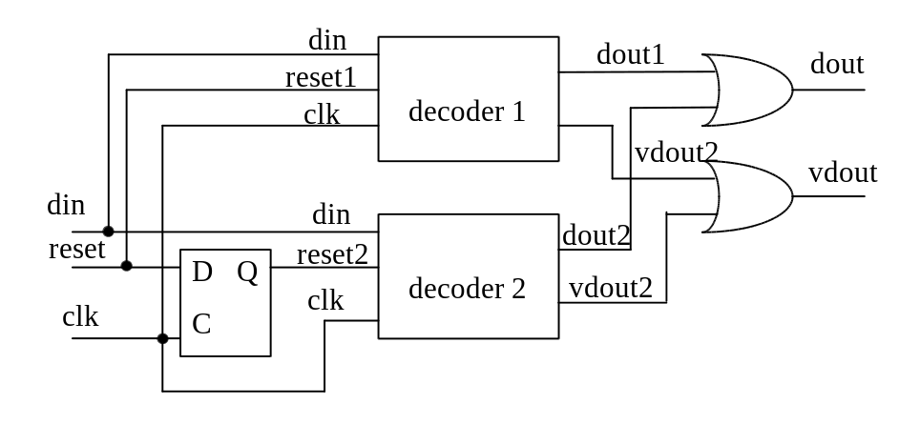
Figure 4.6. A decoder for interleaved BCH codes with interleaving parameter 2.

In conclusion, the interleaving solution is hardware-efficient even when interleaved codes are not being considered. Conversely, the maximum clock frequency at which the circuit is able to cope with decreases when interleaving is adopted and a more complex clock circuit is required. Therefore for some applications, the alternative approach described below may be considered.

The inversionless BMA
The inversionless BMA has been presented in Section 3.4.2, and its block structure is given in Appendix P. The time required to carry out one BMA iteration is reduced to three clock cycles. For every BCH code considered in this thesis the condition 3t < n is met and so no additional interleaving is required (but can still be implemented by the system).

Note, that for the BMA with inversion, σ₀= 1, σ₁= S₁ and β₂ = 0 or 1. Conversely for the inversionless BMA, σ₀ ≠1, σ₁ ≠ S₁ and β₂ ∈ GF(2^{m}), therefore the same simplification of the BMA as in the case with inversion cannot be adopted for the inversionless BMA. A more complex Chien search circuit is also required because σ₀ ≠ 1.

For this approach a fast parallel architecture is adopted. The bit-parallel polynomial basis multiplier option L is used as it can be easily constructed for any m and needs no basis conversions. The VHDL code for this multiplier is given in Appendix K. Additions are also implemented in parallel and so m two input XOR gates are required for each addition.

Unfortunately the inversionless BMA requires t additional multiplications in comparison to the BMA with inversion. The inversionless BMA is implemented using faster but more complex parallel architectures. As a comparison, the hardware requirements of decoders using parallel architectures with the inversionless BMA and serial architectures with the standard BMA are given in Table 4.5. In conclusion, this inversionless approach is not frequently recommended.

Control system
During the development of the design one of the most time-consuming sections of the project was the control system. The control system is implemented as a counter (or two counters for TMEC decoders) and some decoding logic. For encoders and SEC and DEC decoders, the counter is implemented as a circuit for multiplication by α rather than as a binary counter to generate a more hardware-efficient solution. These counters are modulo 2^{m} - 1 = n (the number required in the design) counters and so an additional reset signal is not required. As an example the control system for the (15,5) BCH code encoder is given in Appendix E.

For TMEC decoders two binary counters are required, one to count the number of iterations of the BMA and a second to count the stage of the iteration of the BMA. For interleaving an additional third counter is needed.

The BCS system results
The hardware requirements of some encoders are given in Table 4.1. This table shows: Reg - the number of flip-flops, XOR - the number of 2 input XOR gates explicitly used in the VHDL text files, Area - the synthesis results for combinational logic where this area represents the number of CLBs for the XC3000 family of FPGAs. Note that the area does not represent the actual number of CLBs (in terms of layout) but only the approximate logic complexity, e.g. AND2 and XOR2 = 0.50 CLBs and AND3 = 0.75 CLBs.

m |  | t = 1 | 2 | 3 | 4 | 6 | 8 | 12
3 | Reg  XOR  Area | 8  2  6
4 | Reg  XOR  Area | 10  2  6.75 | 14  4  8.25 | 16  6  9.75
5 | Reg  XOR  Area | 12  2  7 | 17  6  10 | 22  10  13
6 | Reg  XOR  Area | 14  2  7.75 | 20  6  10.75 | 26  10  13.75 | 32  16  18.25 | 41  20  21.25
7 | Reg  XOR  Area | 16  2  8.50 | 23  8  13 | 30  8  13 | 37  16  19 | 51  28  28
8 | Reg  XOR  Area | 18  6  11.25 | 26  12  15.75 | 34  16  18.75 | 42  22  23.25 | 58  32  30.75 | 74  40  36.75 | 102  44  39.75
9 | Reg  XOR  Area | 20  2  9.50 | 29  8  14 | 38  14  17.75 | 47  16  20 | 65  32  32 | 83  40  38 | 119  64  56
10 | Reg  XOR  Area | 22  2  10.25 | 32  8  14.75 | 42  10  16.25 | 52  22  25.25 | 72  28  29.75 | 92  34  34.25 | 132  70  61.25
Table 4.1. The hardware requirements for some BCH code encoders.

Note, that the number of flip-flops is equal to n-k+m+2, (n-k - for the LFSR; m for the modulo n counter; 2 flip-flops for input and output), as would be expected.

As a comparison, the hardware requirements of the equivalent decoders are given in Table 4.2. It can be noticed that decoders are much more complex than encoders.

The number of flip-flops and XOR gates is calculated by the C program and reported in the sim.txt file. Therefore it is possible to establish the hardware requirements of a selected BCH codec without carrying out the difficult and time-consuming synthesis process.

m |  | t = 1 | 2 | 3 | 4 | 6 | 8 | 12
3 | Reg  XOR  Area | 18  5  10.25
4 | Reg  XOR  Area | 29  5  12.5 | 38  29  33 | 106  75  206.75
5 | Reg  XOR  Area | 48  5  14 | 59  38  38.5 | 149  100  246.75
6 | Reg  XOR  Area | 83  5  16.25 | 96  51  50 | 216  116  316 | 250  152  384.75 | 320  219  502
7 | Reg  XOR  Area | 150  5  18.50 | 165  65  59 | 292  138  418.25 | 343  178  497.5 | 445  261  648.25
8 | Reg  XOR  Area | 281  11  22 | 298  108  79.5 | 441  234  607.50 | 499  301  703.25 | 615  434  883.50 | 732  569  1067.7 | 964  810  1423.7
9 | Reg  XOR  Area | 540  5  22 | 559  104  86.75 | 716  197  816.25 | 783  249  918 | 913  366  1112.7 | 1044  499  1315.2 | 1304  792  1719.2
10 | Reg  XOR  Area | 1055  5  24.25 | 1076  127  99.25 | 1251  223  1258.7 | 1323  378  1371 | 1467  399  1585.5 | 1612  531  1806.5 | 1900  827  2249
Table 4.2. Hardware requirements of some decoders.

The number of XOR gates is closely related to the complexity of the circuit. Furthermore, XOR gates are mainly implemented where GF arithmetic is required, therefore a circuit with a low number of XOR gates is usually a control or multiplexing circuit.

In addition to Table 4.2, the hardware requirements for all BCH codes for m= 6 are given in Table 4.3. It can be seen that for SEC and DEC codes the number of XOR gates and the area are quite low in comparison with the number of flip-flops required for buffering. This is especially true for large m.

For t≥3 the buffering is implemented with a clock enable (CE) signal. This architecture is preferred as the global clock can be distributed with low skew rate and therefore without race conditions [55]. On the other hand the PVST does not implement flip-flops with CE and so additional emulating CE logic is required. For t = 1 or 2 the number of flip-flops is constant and equals (n+2) (without additional control logic).
The number of flip-flops for buffering at first increases for increasing t (for t≥3) in spite of less information bits k being stored. This is caused by the increase in the time required to carry out the calculation of the BMA. The maximum number of flip-flops is (2k+1) (one flip-flop is used as an output register, k flip-flops store the information bits whilst calculating the syndromes and up to k flip-flops are required because of the delay in calculating the BMA).

Considering Table 4.3 it can be seen that the most complicated circuit is the BMA. Together, the Chien search and syndrome circuits consist of only about 10-30% of the whole circuit (for t≥3). For t≥10 (m=6) the BMA interleave parameter equals 2 as the number of clock cycles required to carry out the BMA is greater than 63. This requires additional clock enable logic to be implemented for syndrome and Chien search circuits.

 |  |  | decoder
code  k, t |  | en-  coder | syndr. | Chien’s  search | syndr.  rearran | BMA | buffer | control | total
57,1 | Reg  XOR  Area | 14  2  7.75 | 6  2  2.5 | 6  1  5.5 |  |  | 65  1  0.5 | 6  1  7.25 | 83  5  16.25
51,2 | Reg  XOR  Area | 20  6  10.75 | 12  6  5.5 | 12  43  36.25 |  |  | 65  1  0.5 | 6  1  6.5 | 96  51  51.50
45,3 | Reg  XOR  Area | 26  10  13.75 | 18  18  10.75 | 18  18  19.5 | 30  0  40.5 | 56  72  145.75 | 70  1  52.25 | 14  7  33.5 | 206  116  316
39,4 | Reg  XOR  Area | 32  16  18.25 | 24  32  16.5 | 24  28  26.5 | 42  0  63 | 74  84  173.25 | 72  1  53.75 | 14  7  33.5 | 250  152  384.75
36,5 | Reg  XOR  Area | 35  10  13.75 | 27  38  19.75 | 30  39  33.75 | 54  0  81 | 92  96  210 | 73  1  54.5 | 14  7  34.5 | 290  181  447.25
30,6 | Reg  XOR  Area | 41  20  21.25 | 33  52  26 | 36  51  41.25 | 66  0  99 | 110  108  235 | 61  1  45.5 | 14  7  34.5 | 320  219  502
24,7 | Reg  XOR  Area | 47  16  18.25 | 39  67  32.5 | 42  64  47.5 | 78  0  117 | 128  120  270.5 | 49  1  36.5 | 14  7  34.5 | 350  259  556.75
18,10 | Reg  XOR  Area | 53  24  24.25 | 45  96  79 | 60  103  119.75 | 114  0  171 | 182  156  359 | 37  1  27.5 | 17  10  43.75 | 455  366  824.75
16,11 | Reg  XOR  Area | 55  26  25.75 | 47  101  84 | 66  116  132.25 | 126  0  189 | 206  168  390 | 33  1  24.5 | 17  10  43.75 | 489  396  889.25
10,13 | Reg  XOR  Area | 61  26  25.75 | 53  123  97.75 | 78  145  158 | 150  0  225 | 236  192  454 | 21  1  15.5 | 17  10  43.75 | 555  471  1019.7
7,15 | Reg  XOR  Area | 64  30  28.75 | 56  139  107 | 90  178  184.25 | 178  0  261 | 272  216  515 | 15  1  11 | 17  10  43.75 | 624  544  1150.7
Table 4.3. The hardware requirements for encoders and decoders for BCH codes where m= 6 (n= 63), option 3 and optimal interleave (for t<10 interleave=1, t≥10 interleave =2) with design optimisation.

Considering Table 4.3, Fig. 4.7 and Appendices M, N and O, it can be seen that for t=3 there is a rapid increase in hardware requirements in comparison to t=1 and 2. This is because the TMEC algorithm is implemented which requires the additional BMA and syndrome rearranging circuits. For t=3 and m= 6 the number of flip-flops required by the BMA is 56 and the number of XOR gates is 72. Consider further the BMA. The division circuit requires 38 XOR gates (53% of all the XOR gates in the BMA) and 12 flip-flops but this circuit is used only once throughout the TMEC decoder. For increasing t, the number of flip-flops and XOR gates increases linearly (3m flip-flops per error) to store 3 additional GF(2^{m}) values c_{i} (σ_{i}), b_{i} and cc_{i}. The number of XOR gates increases 2m per error for the two additional bit-serial multipliers. The largest component of Area however is taken up by the additional control system, as every flip-flop requires a CE signal and the c_{i} and cc_{i} registers require a synchronous reset. In addition, a multiplexing circuit is required to select new values for the b registers according to the signal dsel (see equ(3.18)). Therefore the increase in Area is about 25 CLBs per error. Furthermore, for TMEC codes, a syndrome rearranging circuit is used which requires 2m flip-flops per error and 2m 2:1 multiplexers per error.

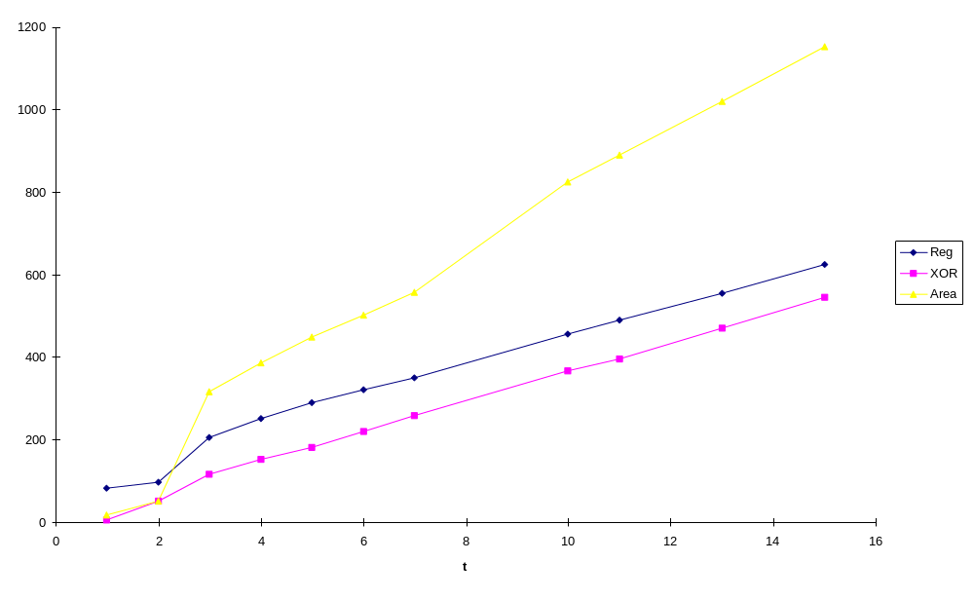
Figure 4.7. The total number of flip-flops, XOR gates and Area for BCH code decoders for m=6 and different t (data taken from Table 4.3)

Consider a Chien Search circuit and it can be seen that it requires m flip-flops per error and some additional XOR gates. It is required to generate (2t-1) syndromes but some syndromes are calculated by the same circuit. For example, syndromes S₃, S₆, S₁₂, S₂₄ are calculated in the same circuit using the same register (see Table 4.4). In conclusion, each new code requires only one additional syndrome circuit and for the rest of the syndrome circuits to be slightly modified.

syndromes | S₃ | S₃, S₆ | S₃, S₆, S₁₂ | S₃, S₆, S₁₂, S₂₄
XOR gates | 6 | 10 | 14 | 18
Table 4.4. The number of XOR gates for the syndrome circuit for m=6 (this circuit always requires 6 flip-flops, despite the number of syndromes to be calculated).

In comparison, the hardware requirements of the serial and parallel inversionless architectures are given in Table 4.5 for the (63, 18) t=10 BCH code. For parallel architectures the number of flip-flops is lower but on the other hand, 3.5 times as many XOR gates are required and the value for the combinational gate area is 2.5 times larger than for the serial case. For this code the interleaving parameter is 2 (for the serial option), and so it can be seen that it is beneficial to implement the serial architecture with interleaving rather than the parallel inversionless architecture.

 |  |  | Decoder
63,18  t= 10 |  | en-coder | syndr. | Chien’s  search | syndr.  rearran | BMA | buffer | control | total
opt 3 | Reg  XOR  Area | 53  24  24.25 | 45  96  79 | 60  103  119.75 | 114  0  171 | 182  156  359 | 37  1  27.5 | 17  10  43.75 | 455  366  824.75
opt 2 | Reg  XOR  Area | 53  24  24.25 | 45  96  43.25 | 66  109  73.25 | 114  0  171 | 132  1193  1693 | 37  1  27.5 | 16  10  39.5 | 410  1409  2071.7
Table 4.5. The hardware requirements for the (63,18) 10 error correcting BCH code for option 3, with interleave parameter = 2 and option 2.

All the results presented here were obtained with design optimisation which is described below.

Design optimisation
Design optimisation is one of the most important but also difficult parts of synthesis. Therefore in the BCS system the hardware requirements have been considered and design optimisation implemented.

Almost every problem can be solved using different algorithms. Therefore the first task is to find an optimal algorithm. Unfortunately for the general case, the optimal algorithm may depend on the selected parameters. Therefore three different approaches have been developed for SEC, DEC and TMEC codes. Similarly, there are two different strategies for syndrome calculation as presented in Section 4.3.1. Therefore the C program chooses the best one considering each individual case as follows. If the number of syndromes using the same minimal polynomial is more than one (e.g. S₃ and S₆ use the same minimal polynomial) or the degree of the minimal polynomial is less than m, the second method of the calculating syndromes is chosen. Otherwise the first algorithm is employed. As an example, the syndrome circuit for the (15,5) code is presented in Appendix H.

Every design represents different trade-offs between area and performance [34]. Therefore in the BCS system hardware efficient serial architectures rather than fast parallel multipliers have been chosen, as the delay between received and decoded data in most cases is not vital.

The next aspect of design optimisation is resource sharing ([37] Chapter 6), where a resource is assigned to more than one operation. For example, the division operation d_{r}⋅d_{p}⁻¹ uses the same multiplier to calculate the inversion d_{p}⁻¹ and then to generate the product d_{r}* d_{p}⁻¹ (see Appendix L). Similarly for syndrome rearranging, the same registers are used to store syndromes and feed these values with the BMA. This is carried out by register rotation (see Appendix O). Since at the beginning of the BMA calculation σ_{i} =0 (i > 1) the value of the corresponding syndrome does not influence the product σ_{i}⋅S_{j} (see equ(3.18)).

Optimisation may also be considered at the logic level, using for example, don’t care (DC) conditions [7], and collapsing and extraction in network restructuring ([13] Section 5.2).

Collapsing consists of eliminating intermediate variables from an expression. For example consider the expressions
inter <= in₁ + in₃; out₁ <= inter + in₄; out₂ <= inter + in₂.
After collapsing:
out₁ <= in₁ + in₃ + in₄; out₂ <= in₁ + in₂ + in₃.
This operation eliminates the number of nodes in a network and is especially useful for nodes with small fan-out, that is, nodes whose fan-out values fall below a defined threshold. Collapsing creates larger nodes and this gives more scope to apply logic minimisation techniques. In addition, this operation may also optimise the technology mapping process, for example the above expressions require 3 LUTs before and 2 LUTs of an FPGA [55] after the collapsing process. Summing up, the final area may decrease after the collapsing process despite the total number of gates increasing.

The inverse operation to collapsing is extraction. Extraction is the process of identifying sub-expressions that are common to two or more logical expressions and creating new intermediate variables. For example consider the following:
out₁ <= in₁ + in₃ + in₄; out₂ <= in₁ + in₂ + in₃. (4.6)
It can be noticed that an intermediate signal can be created as inter <= in₁ + in₃ and in this way one XOR gate is saved, as the addition in GF(2) in₁ + in₃ can be implemented only once. In general, the number of XOR gates saved equals the number of expressions a new intermediate signal can be substituted into minus one (considering only pairs of signals).

Similarly as with collapsing, there is a threshold number of common expressions above which it is beneficial to implement the extracting process. For example, a maximum of 3 XOR gates can be implemented in one LUT (XC4000). Therefore it is beneficial to create an intermediate signal if more than approximately 2 XOR gates can be saved in this way.

As the PVST does not support extracting (only collapsing is available) an extracting function has been implemented in the C program. The number of XOR gates can be significantly reduced in this way. Only XOR gates are considered during the extracting process and the following entities can be minimised: syndrome calculators, Chien search, squaring and raising to the power three. Other parts of circuit cannot be optimised in this way and therefore are not considered during the optimisation cycle. The description of the extracting function is given below.

One of the most difficult tasks of extraction is finding sub-expressions common to two or more expressions (within the same equation) i.e. finding kernels [7]. Fortunately, this task was not required here as only XOR one-level gate expressions are considered, i.e. expressions like equ(4.6). In this design only pairs of common signals are substituted, i.e. signals of the form inter<= sig1 + sig2. In spite of this simplification, the number of possible combinations of extracting expressions increases rapidly with the number of XOR gates and so heuristic algorithms can be only considered (it would be difficult to check every combination of intermediate signals). The procedure is that only a best pair of common signals is substituted into the expressions, and then the procedure is to reapply a new modified signals matrix to take into account the operation performed [7]. Therefore a threshold number is introduced above which a new intermediate signal is created. The procedure is described below:

Initially the threshold number is set to a relatively high number. Then possible combinations of two input intermediate signals are tested until the number of saved XOR gates is greater or equal to the threshold number. If it is, the new intermediate signal is created, and then the seeking operation is reapplied. If all possible combinations of two signals have been tested and none of them meets the threshold inequality, the threshold number is decreased by one and the procedure is repeated again. The procedure is repeated until the threshold (the minimum number of saved XOR gates by one extraction) equals the number specified in the optimisation option (-m). For example, the product circuits after the optimisation procedure are given in Appendices H and J.

The results of this procedure are given in Table 4.6 and also in Table 2.3. Note that extraction considering the good (not the best) pairs of signals (i.e. extracting with the threshold number always equal to 1) gives a result of 82 gates for the considered example in Table 4.6.

 | m=0 m≥5 | m=4 | m=3 | m=2 | m=1
no XOR | 125 | 109 | 97 | 81 | 70
Table 4.6. The number of XOR gates in the dpow3 (raising to the power 3) entity for GF(2⁸) after the extraction process. m=0 - without extraction, m= 1,2...- the minimum threshold number is equal m.

Table 4.7 presents overall design extraction results for the (63,18) 10 error correcting BCH code. It can be seen that the syndrome circuit is the most significantly minimised circuit whereas with the Chien Search circuit only one XOR gate has been saved. For other circuits, the extracting process has not been implemented (except for the squaring circuit but no minimisation has been achieved for m=6, see Table 2.3).

 |  |  | Decoder
63,18  t= 10 |  | en-coder | syndr. | Chien’s  search | syndr.  rearran | BMA | buffer | control | total
with optim | Reg  XOR  Area | 53  24  24.25 | 45  96  79 | 60  103  119.75 | 114  0  171 | 182  156  359 | 37  1  27.5 | 17  10  43.75 | 455  366  824.75
with  out | Reg  XOR  Area | 53  24  24.25 | 45  164  92.5 | 60  104  120 | 114  0  171 | 182  156  359 | 37  1  27.5 | 17  10  43.75 | 461  435  838
Table 4.7. The hardware requirements of the (63,18) 10 error correcting BCH code decoder, for option 3, with interleave =2, (-m1) and without design optimisation.

Table 4.8 shows the results of extracting for syndromes. For more complicated syndrome circuits the results of optimisation are better, and the number of gates saved in one extraction increases, as would be expected.

t | 2 | 3 | 4 | 5 | 6 | 7 | 10
-m0 | 6 | 22 | 43 | 56 | 82 | 102 | 164
-m2 | 6 | 20 | 36 | 43 | 58 | 72 | 107
-m1 | 6 | 18 | 32 | 38 | 52 | 67 | 96
Table 4.8. The number of XOR gates required in syndrome circuits for m=6 and different error correcting capabilities t.

Design simulation
One of the most difficult and time-consuming processes of every design is its simulation. Therefore the BCS system generates an additional circuit - included in sim.vhd - in order to thoroughly simulate the design. Random input and error values are generated by the C program and exported into simulation command files. Then the simulation circuit shown in Figure 4.8 is simulated. During simulation, input data is automatically compared with encoded-corrupted-decoded data, and if they differ a ‘wrong’ signal is asserted in order to indicate that the circuit is faulty. In this way even someone not familiar with BCH codes can easily detect a faulty design. This kind of simulation is especially efficient for large codes, when simulation by hand would be difficult or even impossible (the simulation program gives a system error if the displayed vector is very long, e.g. 1013 bits for a (1023, 1013) BCH code). In addition, the simulation can be as long as the designer wishes as the C program asks for the number of input vectors to be simulated. The simulation length is a compromise between time of simulation and design reliability, the design was simulated for about 10 codewords for large codes and 200 for small ones. The circuit can be simulated before and after synthesis and so two different simulation command files are generated, sim.cmd before and sim.cme after synthesis. A more detailed figure of the simulation circuit is given in Appendix Q.
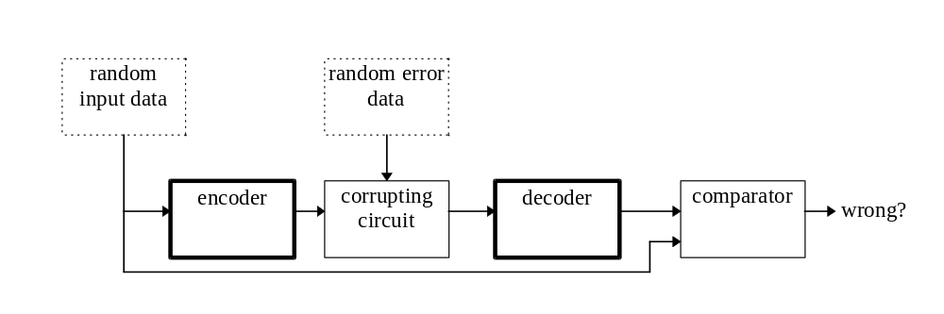
Figure 4.8. The circuit for simulation.

Conclusions
In this chapter the BCH codec synthesis (BCS) system has been described. The BCS system consists of a C program and templates. At first, the system user enters the parameters of a BCH code (such as m and t) and the design options into the C program. Then the C program generates VHDL files using VHDL templates. These VHDL files can be synthesised using the PVST. The advantages of this hybrid system are that the C program significantly simplifies the design as more complex and faster functions can be easily employed, and also, design optimisation and the creation of auxiliary files can also be carried out.

Designing any BCH codec is a difficult task because the optimum algorithm changes for different BCH codes. Hence three different approaches for decoding have been implemented for SEC, DEC and TMEC codes. The choice as to which algorithm to use in the decoder is automatically made by the BCS system.

The BCS system also makes the assumption that an encoder should send data without wait sates. Similarly a decoder is bound to receive continuous data, despite some BCH codes requiring the time taken to calculate the BMA being greater than the time taken to receive the data. Therefore two different approaches have been considered for TMEC codes, the parallel inversionless architecture and the serial architecture. Furthermore the serial architecture may be modified in order to increase the speed of operation of the BMA - the most hardware-demanding element of the decoder. As a result, the BMA may be clocked at a higher frequency than the rest of the circuit, and the interleaving parameter may be introduced. This parameter may also significantly simplify the decoding process of interleaved codes. In conclusion, the serial architecture is preferred to the parallel architecture, but this option should also be considered for BCH codes for which interleaving is required for a serial architecture.

It should be observed that the new architectures described in Chapter 2 have been utilised in the BMA. The proposed circuit generating the sum of products allows t LFSRs to be saved (that is, m*t flip-flops and (t-2) XOR gates for m≠8 or (3t-4) XOR gates for m=8). In addition, a new Dual-Polynomial Basis Multiplier option B has been developed. It has been shown that these circuits can be easily combined to form an efficient BMA circuit with respect to hardware requirements and time taken to produce a solution. By this method, the number of clock cycles per iteration of the BMA has been almost halved. This ensures that more decoders can be implemented using the serial architecture (without interleaving) and that the number of buffering flip-flops is also reduced because of this lower calculation time.

The results of synthesis have also been considered and as would be expected, the hardware requirements of encoders are notably lower than those of equivalent decoders. As a result of using different algorithms, there is a rapid increase in the hardware requirements of TMEC decoders in comparison to the SEC and DEC decoders. For SEC and DEC decoders most of the hardware is required by the buffering circuit. For TMEC decoders the most hardware intensive element of the design is the BMA. With the inversionless option there is a noticeable increase in hardware requirements in comparison to the standard BMA.

Design optimisation has also been used in the BCS system. Optimisation can be implemented at a high level of abstraction, when different algorithms may be used (for example the SEC, DEC, or for the general case the TMEC algorithms) and resource sharing can be adopted. This level of optimisation is usually considered during design writing. But in the case of the BCS system, algorithmic optimisation has also been adopted in the design of the C program (selecting different circuits to generate the syndromes for example). Optimisation has also been considered at the logic level and the extracting process has been implemented in the C program.

The codecs produced by the BCS system have been thoroughly simulated before and after synthesis. To achieve this an additional simulation circuit has been developed (sim.vhd). The C program generates random data and exports it into simulation command files. These files can then be used to run simulations within Powerview.

In conclusion, the codecs produced by the BCS system are as hardware efficient as hand-crafted ones, and the time taken to design any BCH codec has been drastically reduced. Therefore the aims of this thesis have been completely met.

